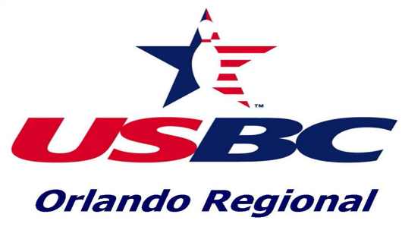

ELIGIBILITY RULES

Any graduating High School Senior student is eligible to make an application for this scholarship. Providing his or her amateur standing is maintained and the student meets the following requirements:
- Student files an application furnished by the Orlando Regional USBC, giving complete information as required thereon, before June 15th of their year of eligibility, with the Association Manager of the Orlando Regional USBC.
- Applicant must have unimpaired amateur standing in all athletics.
- College students may apply provided they applied in their senior year of High School and was not awarded a scholarship.
- Applicant must be a member of a certified bowling league within the jurisdiction of the Orlando Regional USBC and must be in good standing for the current season.

IF YOU COMPLY WITH THE ABOVE ELIGIBILITY RULES, PROCEED WITH THE FOLLOWING:

- Complete the Applicant Data form of the application in its entirety, ensuring that all lines have been completed. Make note of any information request that does not apply with a “N/A”. Please type or print clearly.
- Have your bowling coach complete the Coach’s evaluation form.
- Be sure that you, the applicant, and your League Coach sign their respective pages.
- Write an essay of 200-250 words, expressing why you wish to attend college and what your future plans might be.
- Request a copy of the most current transcripts from your High School or College. Submit this, along with all other required information to the Association Manager of the Orlando Regional USBC, whose address is listed below.
- Please review all pages of the completed application for accuracy and completeness. ANY

INCOMPLETE APPLICATIONS WILL NOT BE CONSIDERED FOR A SCHOLARSHIP. The
Association Manager of the Orlando Regional USBC must RECEIVE all applications and required additional information by June 15th of the year you are graduating.

If you should have any questions or need further assistance, please contact the Orlando Regional USBC Association Manager at (407)447-4622 or orlandoregionalusbc@gmail.com
Email or Mail ALL application packages to: Association Manager
orlandoregionalusbc@gmail.com

Orlando Regional USBC 10749 E Colonial Drive Orlando, FL 32817
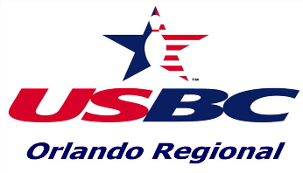

APPLICANT NAME: DATE:

MAILING ADDRESS:

CITY: STATE: ZIP:

EMAIL:

PHONE NUMBER: DATE of BIRTH:

SCHOOL YOU ARE NOW ATTENDING:

USBC MEMBERSHIP#: MEMBERSHIP SINCE (YEAR):

OFFICES HELD IN YOUTH OR JUNIOR LEAGUES (TEAM CAPTAIN, LEAGUE OFFICER):

ARE YOU ACTIVE IN CLASS OR SCHOOL ORGANIZATIONS? YES NO

IF SO, PLEASE LIST A FEW OF YOUR ACTIVITIES/RESPONSIBILITIES:

WHAT TWO BOWLING ACCOMPLISHMENTS MEANT THE MOST TO YOU AND WHY?

WHAT IS YOUR INTENDED COURSE OF STUDY?

FATHER’S FULL NAME: PHONE #:

MOTHER’S FULL NAME: PHONE #:

ADDRESS OF PARENT, IF NOT THE SAME AS APPLICANT:

TO MY KNOWLEDGE, THE ABOVE STATEMENTS ARE CORRECT.

SIGNATURE of APPLICANT

COACH’S EVALUATION & DATE SHEET
(Please type or print clearly)

APPLICANT NAME: DATE:

NAME of COACH: PHONE NUMBER:

NAME of CENTER(S) WHERE APPLICANT BOWLS:

NUMBER of YEARS APPLICANT HAS BOWLED IN YOUTH/JUNIOR LEAGUES?

NUMBER of GAMES IN CURRENT SEASON FOR EACH LEAGUE:

DOES APPLICANT KNOW HOW TO KEEP SCORE MANUALLY? | YES | NO
DOES APPLICANT OBSERVE RULES of LANE COURTESY? | YES | NO
DOES APPLICANT KNOW HOW TO COMPLETE A LEAGUE RECAP SHEET?  DOES APPLICANT FOLLOW ALL USBC RULES AND DISPLAY EXEMPLARY SPORTSMANSHIP DURING LEAGUE AND TOURNAMENT PLAY? | YES  YES | NO  NO
DID APPLICANT BOWL IN the most recent ASSOCIATION TOURNAMENT? | YES | NO

COACH’S RECOMMENDATION: (Important):

SIGNATURE of COACH

